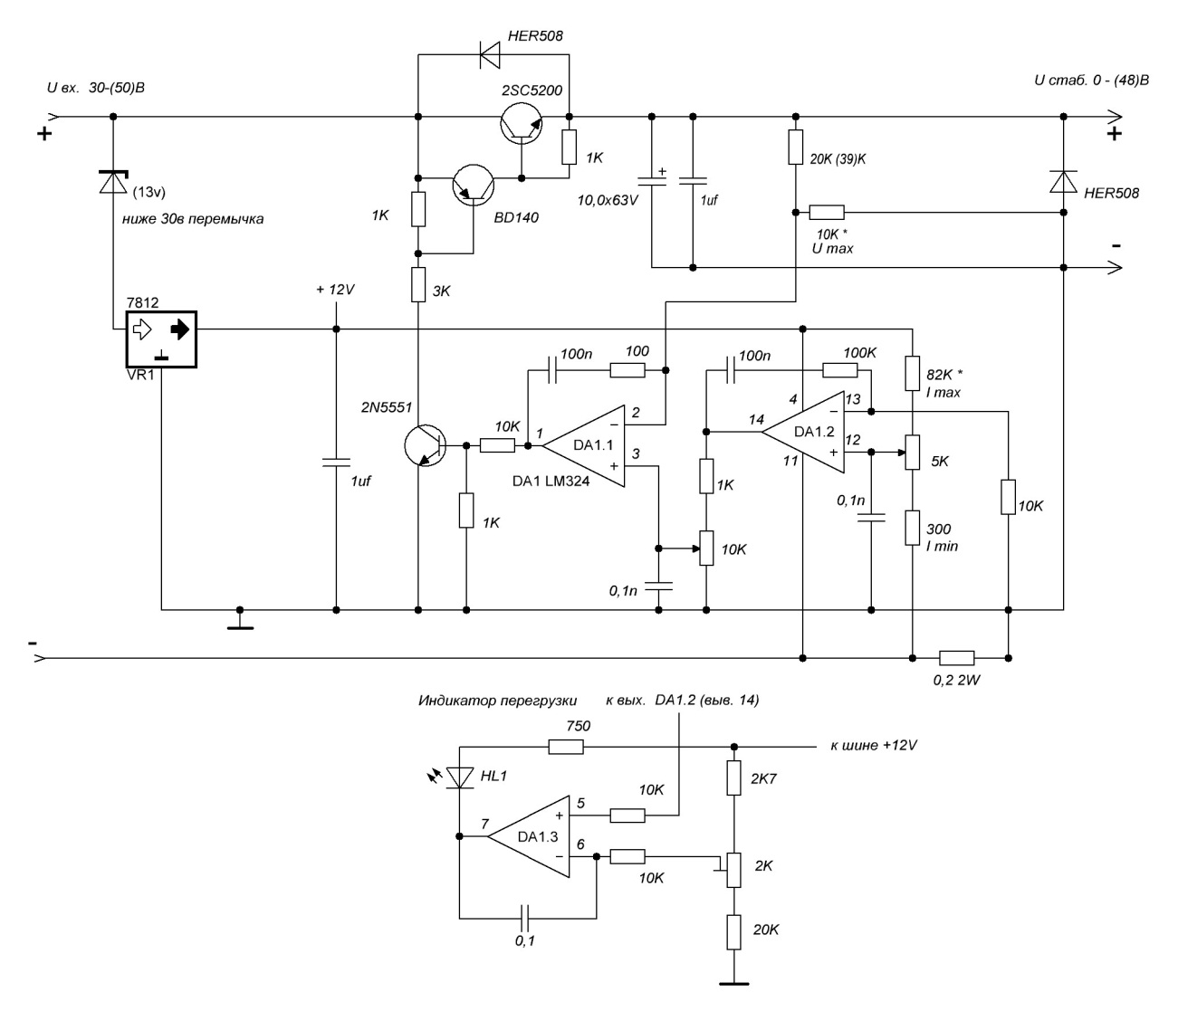

FONTE <https://www.youtube.com/watch?v=jxb3D9j_350>

FONTE .<https://forum.cxem.net/index.php?/topic/76820-%D0%BF%D1%80%D0%BE%D1%81%D1%82%D0%BE%D0%B9-%D0%B8-%D0%B4%D0%BE%D1%81%D1%82%D1%83%D0%BF%D0%BD%D1%8B%D0%B9-%D0%B1%D0%BF-050%D0%B2/page/9/#comments>

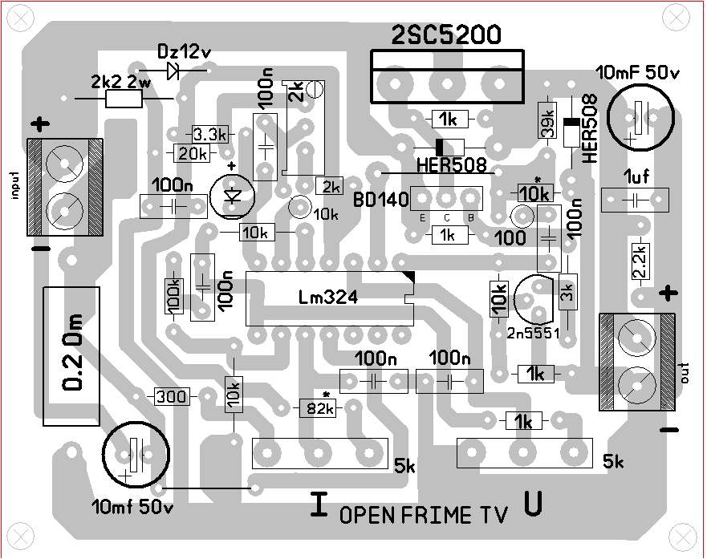

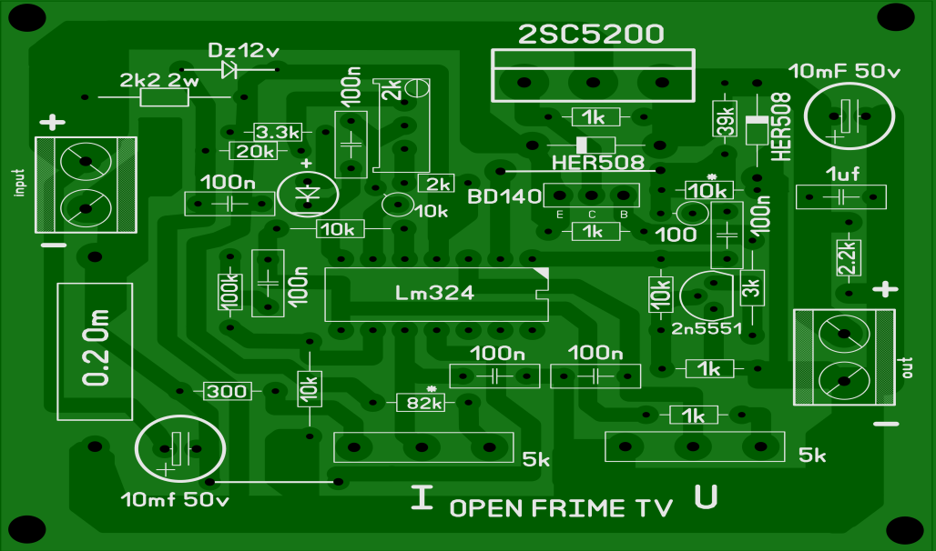

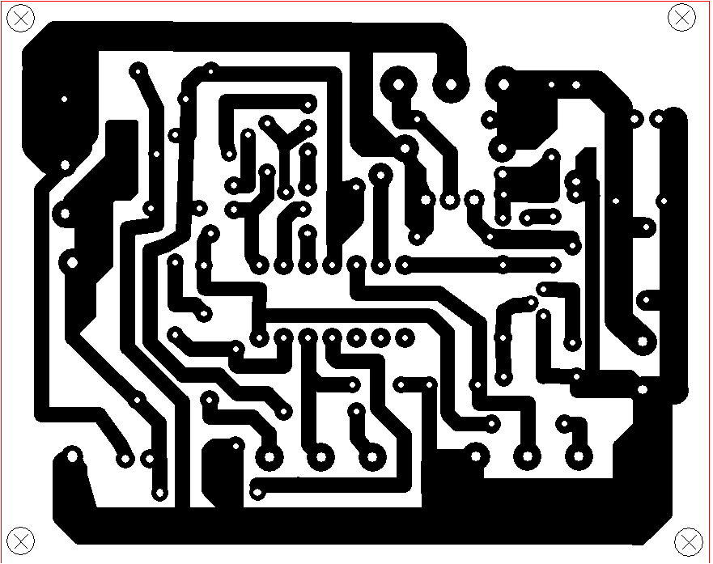

Tamanho Real 7.46 x 5.90cm