Toroidal cores
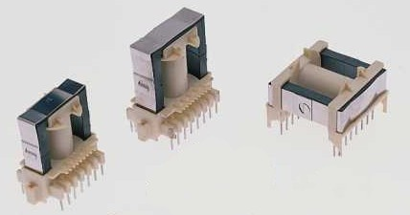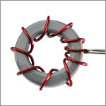
ETD-type cores
Toroid from ITL 100 inductor (Wilco Corp).
(Remove the thick wire before winding! :-)
These are a few general winding guidelines for all types of cores:
- You MUST use enamelled copper wire for all the windings. Keep also in mind that when working with high frequencies, the effective section of the wire is much smaller than the physical one, due to the "skin" effect (the current concentrates only in the outer part of the wire). As high currents are involved here, the section of the wire is very important, (if you don't want the enamel to fuse due to the heating produced by the resistive losses of the wire and short all the windings). A good practice is to use several thinner wires in parallel rather than a single thick one. This also eases winding. For example, six 0.4mm diameter wires can form a suitable primary for a 300W supply. The same applies to the secondary, although the current is reduced so you can use less wires (3 or 4, for example). From now on, I will refer to each composite wire as "winding", and to each thin wire as "wire".
- The wires must be tightly wound. You must wind the primary first, trying to cover all the surface of the core, and then the secondary over it in the opposite direction, to maximise inter-winding coupling.
- A good starting point is using 4 turns for each primary (that is, 4 turns, centre tap and another 4 turns IN THE SAME DIRECTION). To calculate the number of turns of the secondary winding, multiply by the turns ratio. For example, if you want to build a +/-30V supply, the turns ratio is 30/13.8=2.2 approx, so wind 2.2 x 4 = 8.8 turns (better 9 turns, to overcome the diode losses) for each secondary (that is, again, 9 turns, centre tap and another 9 turns IN THE SAME DIRECTION).
- To start winding, take the number of thin wires you have decided to use (6, for example) in the primary, all together. Leave about 3 or 4 cm out of the core to ease connection to the board and start winding. When you have wound 4 COMPLETE turns, go out the core and cut at 3 or 4 cm. Now you have the first primary. Then start again IN THE SAME DIRECTION winding the other 4 turns and at the end leave another 3 or 4 cm for connection. Twist together the thin wires of each winding at the ends, to ease soldering.
- The varnish of the wire is intended to provide electrical isolation, so you have to remove it at the ends to make the connections to the board. Be sure to remove about 1cm to the end in ALL the wires you use. You can do that using a special solvent or with sandpaper and a lot of patience BEFORE winding.
The following are photos of two models of transformers. The left one is a toroidal I wound myself using the core from a big inductor from Wilco Corporation (ITL-501), and the right one is a commercial unit from a US manufacturer (2x3:1, 350W). Both 